Nebraska Resources
NEVCAP (Nebraska Victims of Crime Alert Portal)
24/7 Advocate Line: 1-800-395-2110
https://ncc.nebraska.gov/nebraska-victims-crime-alert-portal

Nebraska Department of Corrections Victim Services Connie Pfeifer, 402-290-6203
Staff Advocate & Victim Services Coordinator
https://www.corrections.nebraska.gov/public-information/victim-services

Nebraska Coalition to End Sexual & Domestic Violence
402-476-6256
https://www.nebraskacoalition.org/

Nebraska Department of Justice Victim/Witness Assistance
Macy Meyer, 402-471-3823
https://ago.nebraska.gov/victim-assistance-program

Nebraska Crime Victim Reparations
Gretchen Mills, 402-471-2828
https://ncc.nebraska.gov/crime-victim-reparations

Nebraska Victim Advocacy Program
Julie Geise, 402-429-1609
https://ncc.nebraska.gov/nebraska-victim-advocacy-program

Nebraska Alliance of Child Advocacy Centers
402-933-7422
https://www.nebraskacacs.com/

US Attorney's Office Victim Assistance
402-661-3700
https://www.justice.gov/enrd/environmental-crime-victim-assistance/assistance-and-resources-victims

Mothers Against Drunk Driving Nebraska
402-434-5330
https://madd.org/

Nebraska Army/Air National Guard Sexual Assault Prevention & Response Program
402-309-8176
https://ne.ng.mil/Resources/Prevention-Response/Sexual-Assault-Prevention-and-Response/

Nebraska Board of Parole
Board of Parole
PO Box 94754
Lincoln, NE 689509
https://parole.nebraska.gov/

Information for Victims is available on the website:
https://parole.nebraska.gov/content/information-victims

After Hours Statewide Emergency Phone: 402-310-5017

National Resources
Rape, Abuse, Incest National Network
1-800-656-HOPE (4673)
https://www.rainn.org/

Victim Connect National Hotline
1-855-484-2846
https://victimconnect.org/

National Domestic Violence Hotline
1-800-799-SAFE (7233)
https://www.thehotline.org/

National Suicide Prevention Lifeline
988
https://988lifeline.org/

Nebraska’s Network of Domestic and Sexual Violence Programs
The Nebraska Coalition to End Sexual & Domestic Violence provides a detailed list of Nebraska programs, available on the website.
https://www.nebraskacoalition.org/ | 402-476-6256
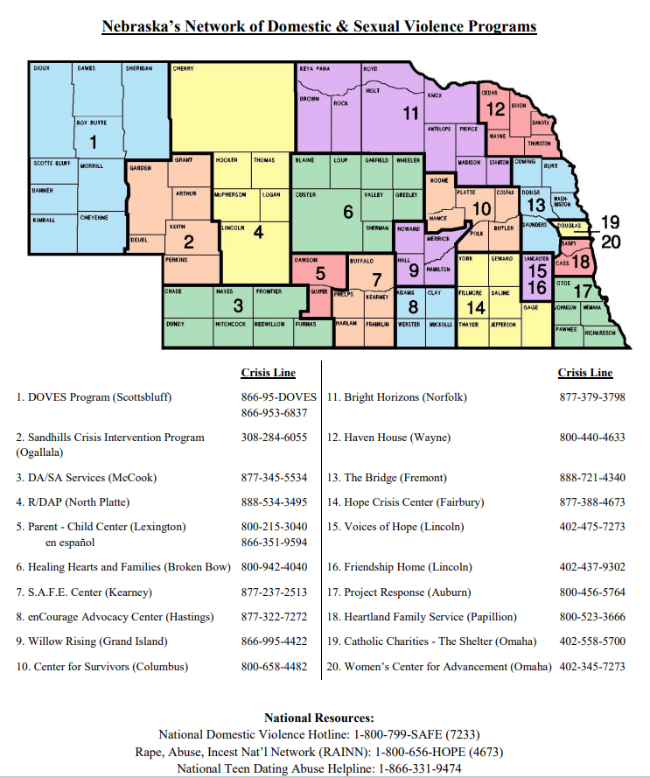
Victim/Witness Assistance Programs
Adams County Victim/Witness Unit - Hastings
402.461.7240
https://adamscountyne.gov/county-attorney

Buffalo County Crime Victim Assistance - Kearney
308.233.5263
https://cityofkearney.org/692/VictimWitness-Assistance

Butler & Polk Victim Assistance Program – David City
402.367.7405
https://www.countyoffice.org/butler-polk-county-victims-assistance-david-ne-5b0/

Dakota County Victim Assistance Unit – South Sioux City
402.494.7550
https://dakotacounty.ne.gov/webpages/attorney/victim_assistance.html

Dawson County Victim Witness Assistance Unit - Lexington
308.324.5702
https://www.dawsoncountyne.gov/administrative/county_attorney.php

Dodge County Victim Services - Fremont
402.727.2795

Douglas County Victim Assistance – Omaha
402.444.4597
https://countyattorney.douglascounty-ne.gov/victim-assistance

Gage County Victim Assistance - Beatrice
402.223.4080
https://gagecountysheriff.us/victim-assistance-program

Hall County Victim Witness Program – Grand Island
308.385.5409
https://www.gipolice.org/services/victim-assistance-program

Keith County Victim Witness Unit – Ogalla
308.284.2091

Lancaster County Victim Witness Unit - Lincoln
402.441.7181
https://www.lincoln.ne.gov/City/Departments/Police/Departments/Victim-Assistance
Lincoln County Victim Witness Unit – North Platte
308.534.4350

Madison County Victim Assistance Unit - Madison
402.454.3311 ext. 217
https://madisoncountyne.gov/county-attorney/

Nebraska Victim Advocacy Program - Statewide
402.42931609
https://ncc.nebraska.gov/nebraska-victim-advocacy-program

Platte & Colfax County Victim Assistance - Columbus
402.563.4971
https://plattecounty.ne.gov/victim-assistance/

Saline County Victim Assistance – Wilber
402.821.2531

Sarpy County Victim Witness Unit - Papillion
402.593.2201
https://www.sarpy.gov/434/Victim-Witness

Saunders County Domestic Violence Assistance - Wahoo
402.443.8163

Scotts Bluff County Victim Witness Assistance - Gering
308.436.6674 #1
https://www.scottsbluffcountyne.gov/attorney-county/attorney-county-Victim-Witness-Assistance-Unit.html

Scotts Bluff Victim Assistance | Police Department - Scottsbluff
308.632.0017

Seward County Victim Services - Seward
402.641.2455
https://www.sewardcountyne.gov/victimsassistance

