Covariate Influences on Recidivism Rates for Nebraska Prisoners

Nebraska Statistical Analysis Center (SAC)

11th May 2021

*Revised –* 17th April 2023

The purpose of this study is to investigate several covariates and their impact on recidivism rates and desistance for Nebraska’s adult prisoner population. In doing so, we seek to identify patterns in recidivism and desistance while controlling for several extraneous variables across multiple time points. To address this objective, we propose the following two research questions:

1. How do recidivism rates differ across time when controlling for sex, age, race, court district, offense type, criminal history, incarceration length, and parolees?
2. How does desistance differ across time when controlling for sex, age, race, court district, offense type, criminal history, incarceration length, and parolees?

METHOD

*Data Sources*

The data used in this recidivism study are publicly available at <https://dcs-inmatesearch.ne.gov/Corrections/COR_download.htm>. For example, the 2016 cohort would include 2,217 Nebraska adult inmates who have a release date between January 1, 2016 and December 31, 2016. Previous cohort years will also be included in this investigation.

*Measures*

Two dependent variables will be measured, recidivism and desistance. We operationally define *recidivism* as any conviction(s) that occurred within a five-year window after a prisoner’s release date. If an individual is found to have recidivated during this timeframe, then crime information from both the original sentence and the subsequent recidivism event will be compared to determine the *desistance* measure.

The hierarchical structure of NCIC codes will provide the foundation for determining *desistance*, such that if the recidivating individual is observed to have a lesser NCIC value than the most serious crime from his/her original sentence, then the individual will be deemed to have desisted. Offense data downloaded from the Nebraska Department of Correctional Services website will be cross-mapped to the Uniform Offense Data Codes from the NCIC Code Manual as of March 31, 2012 (see <https://docslib.org/doc/12611995/ncic-code-manual-as-of-march-31-2021-article-data-codes-as-of-march-31-2021-article-data-codes-table-of-contents>).

*Covariates*

Both dependent measures – (a) resistance and (b) desistance – will be compared across eight independent/grouping variables. More information on these eight covariates is provided below (with descriptive statistics provided for the 2016 cohort):

1. Sex (*l* = 2)

* Male = 1,919 (86.6%)
* Female = 298 (13.4%)

1. Age Group (*l* = 5)

* Under 24 years
* 25 to 29 years
* 30 to 34 years
* 35 to 39 years
* Over 40 years

1. Race (*l* = 6)

* White = 1,343 (60.6%)
* Black = 521 (23.5%)
* Hispanic = 239 (10.8%)
* Asian/Pacific Islander = 7 (0.3%)
* Native American = 90 (4.1%)
* Other/Unknown = 17 (0.8%)

1. District (*l* = 12) – <https://supremecourt.nebraska.gov/directories/district-court-judges>

* X

|  |  |  |  |  |  |  |  |  |
| --- | --- | --- | --- | --- | --- | --- | --- | --- |
| Inmates Released by Court District across Cohort Years | | | | | | | | |
| District | 2016 | | 2015 | | 2014 | | 2013 | |
| *n* | *%* | *n* | *%* | *n* | *%* | *n* | *%* |
| 1 |  |  |  |  |  |  |  |  |
| 2 |  |  |  |  |  |  |  |  |
| 3 |  |  |  |  |  |  |  |  |
| 4 |  |  |  |  |  |  |  |  |
| 5 |  |  |  |  |  |  |  |  |
| 6 |  |  |  |  |  |  |  |  |
| 7 |  |  |  |  |  |  |  |  |
| 8 |  |  |  |  |  |  |  |  |
| 9 |  |  |  |  |  |  |  |  |
| 10 |  |  |  |  |  |  |  |  |
| 11 |  |  |  |  |  |  |  |  |
| 12 |  |  |  |  |  |  |  |  |

1. Offense Type (*l* = 4)

* Violent
* Drug
* Property
* Other

1. NCIC Offense Categories Groupings (*l* = 13)

* Homicide
* Kidnapping
* Sexual Assault
* Robbery
* Assaultive Act
* Burglary
* Compliance
* Dangerous Drugs
* Family Offense
* Property & Fiscal
* Traffic Offense
* Weapon Offense
* No Crossover

1. Criminal History (*scale*) – number of previous convictions
2. Parolee (*l* = 2)
3. Incarceration Length (*scale*) – number of days between beginning of sentence and release date

*Analysis*

Survival analysis, or more appropriately named failure analysis, will be conducted in this study. One benefit of using failure analysis resides is its flexibility. In particular, this method does not require any distributional assumptions of the covariates and may include both continuous and discrete variables as covariates. However, the primary limitation of this ad hoc study (and survival analysis in general) is its inability to make causal inferences due to its reliance on historical/administrative data.

Upon completion, the findings of this study will be available on the Nebraska Crime Commission (NCC) website.

**2016 Cohort Notes**

1,967 releasees

828 unmatched

57.9% (lower)

MASTER = NDCS Public Data

USING = JAMIN

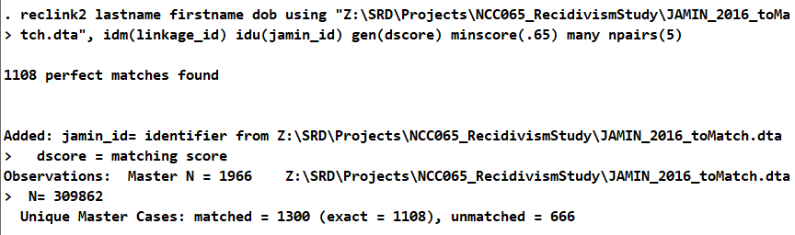

**2015 Cohort Notes**

2,206 unique cases released

**Matching Results**

import excel "Z:\SRD\Projects\NCC065_RecidivismStudy\2015_JAMIN_Matches.xlsx", firstrow sheet("Stata_Import") clear

tab2 match details

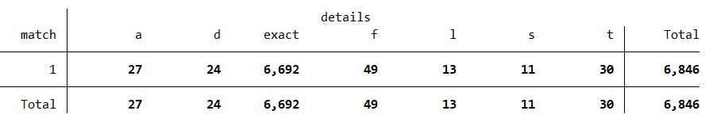

a = abbreviated first name

d = dob 1 digit

f = first name slight misspelling

l = last name slight misspelling

s = suffix missing

t = two surnames

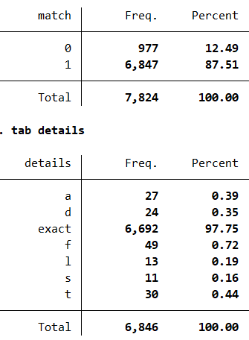

56% recidivism

**2014 Cohort Notes**

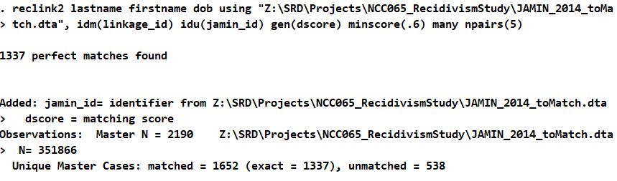

**2013 Cohort Notes**

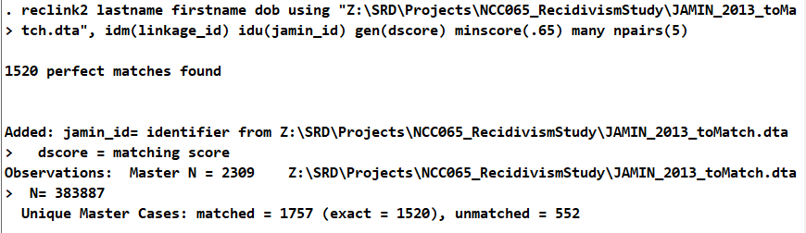

**2012 Cohort Notes**

Xxxx

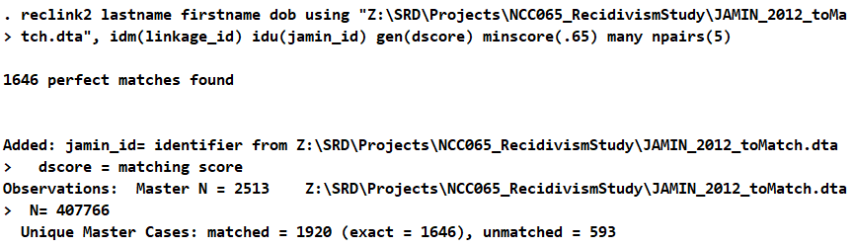

**2011 Cohort Notes**

Xxx

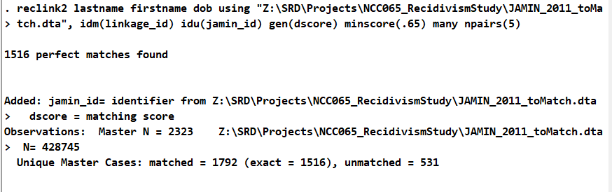

**2012 BJS National Recidivism Study**

Youtube - [(459) National Corrections & Recidivism Statistics - YouTube](https://www.youtube.com/watch?v=AbFVR3f3tpI)